Risk Management Plan
  - <Project Name>
  - <Author>

Version History
[Use the following table to track various revisions of your document. Minor revisions are decimals (such as spelling and grammar changes). Major revisions are whole numbers (such as filling in sections or making sweeping changes to the document)]

Version # | Author | Date | Summary
1.0
[Instructions: All boilerplate text (text this color) is to be replaced with your own text. When finished, please submit the final document as a DOCX file.]

Introduction

Purpose Of The Risk Management Plan
[What is this document meant to accomplish?]

Risk Management Procedure

Process
[Summarize how data was collected and final recommendations were written.]

Risk Identification
[Enumerate all the risks (both positive and negative) that may be encountered while completing your Senior Project. Some categories that you may wish to consider: Technical, Personal, Academic, Intellectual, etc.]

Risk Analysis
[See: “Analyze the Risks.” Most of this will be in 3.3.1 and 3.3.2.]

Qualitative Risk Analysis
[For each risk, determine the probability and threat of each risk the prioritize the risk. Note that “Qualitative” means “descriptive”. No numbers here, just a textual explanation of the probability and threat of each risk]

Quantitative Risk Analysis
[For each risk, determine a quantitative score. There will be two components: the probability and the threat. Both should be in sync with the Qualitative Risk Analysis description previously done. Then compute a final risk value based on the following table. The table need not be included in the final report.]
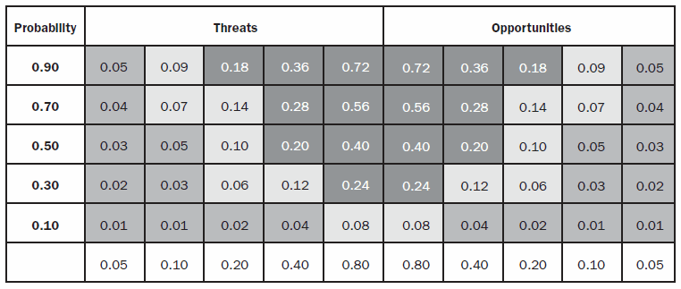

Risk Response Planning
[See: “Planning Risk Response.” For each risk, how will it be addressed? For negative risks, you may wish to Avoid, Mitigate, Accept, or Transfer. For positive risks, you may wish to Enhance, Exploit, Share, or Accept. In each case, make sure your response planning represents something you actually intend on doing during your senior project. ]

Risk Monitoring, Controlling, and Reporting
[See: “Monitor and Control Risk” part of the reading. For each risk, describe how you will know to activate your response plan (Risk Monitoring), how you will know that the response plan is functioning the way it was intended (Controlling), and how you will contact stakeholders to inform them of the status of a given risk (Reporting)]

Appendix A: References
[Any document our source that was used to produce this document. Use the citation format used elsewhere in this class.]

Appendix B: Key Terms
[If you use any terms in a special way, describe them here]
Term | Definition

